FOR IMMEDIATE RELEASE

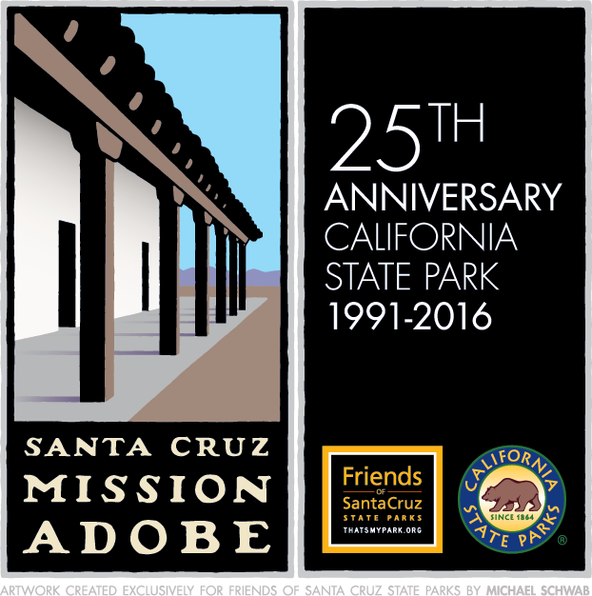
SANTA CRUZ MISSION STATE HISTORIC PARK 25TH ANNIVERSARY MURAL CONTEST WINNERS ANNOUNCED

COMMUNITY WORK DAYS ARE PLANNED TO CREATE AND INSTALL THE MURAL

MAY 6, 2016 – SANTA CRUZ, CA—Friends of Santa Cruz State Parks (Friends), a local non-profit supporting dozens state parks and beaches in Santa Cruz and San Mateo counties, today announced a design by two Mission Hill Middle School students has been chosen for the new Santa Cruz Mission State Historic Park mural in celebration of the 25th Anniversary of the opening of the park.

Katherine Tkoch, 12, and Flora Chatwin, 13, submitted separate designs in the contest, which was held in March. The Mural Selection Committee liked elements of both girls' work. The students worked with their teacher, noted local artist Kathleen Crocetti, to combine their designs.

“Our call for mural designs received an great response from local students, artists and community members,” said Bonny Hawley, executive director of Friends. “With all the great work, we chose to select elements from two designs, and are pleased Katherine and Flora were open to merging their creative talents for what will surely be a beautiful public art installation.”

Santa Cruz Mission State Historic Park is located at 144 School St. in Santa Cruz. Designed to draw visitors to the park, the mural will be located on a series of existing retaining walls along the park’s Mission Street boundary, facing downtown. The mural site is at the stairway entrance to the park, adjacent to Mitchell Properties on Mission Street and up the hill from the Town Clock.

The combined design will be recreated in tesserae, a colorful tile that will be formed in the shape of the artist’s design to create the mosaic mural. Drop-in work days to help with the mural will be held 5-8 p.m. Tuesday to Thurdasy, May 10-12 at Mission Hill Middle School classroom #5, 425 King St, Santa Cruz. Enter through the back door from the gated parking lot.

Community volunteers and Mission Hill Middle School students, in cooperation with Friends and California State Parks, will install the public art May 21-23. The installation will take place under the direction of Crocetti, who has created murals on the Water Street, Soquel Avenue and Laurel Street bridges, and many other locations in the county. Students from Mission Hill Middle School will apply the finishing touches May 23, 2016.

Volunteers for the mural installation must be 18 or older. Kids ages 11-17 must be accompanied by an adult. Because the mural-making involves working with sharps shards, the project isn’t open to children younger than 11. For questions, contact Amanda Segers at 831-429-1840, ext. 103 or Amanda@ThatsMyPark.org.

The Santa Cruz Mission State Historic Park Community Mural is funded through a generous grant from Arts Council Santa Cruz County and support from Friends of Santa Cruz State Parks in honor of the Adobe Collation, with additional assistance from California State Parks, the City of Santa Cruz, Rinaldi Tile and Marble, Diamond D Concrete and Kathleen Crocetti.

About Santa Cruz Mission State Historic Park
The Santa Cruz Mission State Historic Park, “Your State Park Downtown,” is home to the oldest building in Santa Cruz County. Built between 1822 and 1824 by local Ohlonean and Yokuts Indians, the park’s signature adobe is the only remaining structure from Mission Santa Cruz, founded in 1791. One of just four adobe buildings left in Santa Cruz County — and sometimes confused with the nearby replica mission chapel — it is the only building of its kind preserved as a museum in the State of California. The adobe served as housing for Neophyte families who lived and worked at the Mission, which operated until 1834 when it was secularized. After decades of private ownership, the adobe was sold to the State of California, extensively restored and finally opened in 1991 to the public as the Santa Cruz Mission SHP. The park celebrates its 25th year in 2016.

Friends of Santa Cruz State Parks saved Santa Cruz Mission SHP from closure in 2012. Friends funds interpretation services and a portion of park operations, and also runs the Mission ParkStore. In addition, Friends has implemented key improvements at the park, including a remodel of the patio, the opening of new interpretive exhibits, renovated outdoor cooking facilities and new hours of operation to serve local school children. Friends also established the Summer Series, a popular series of cultural events at the Mission that culminates with the Mole & Mariachi Festival each September. The park is supported by the Mission Committee, members of which include representatives of Friends, State Parks and dedicated community volunteers. For more information about Santa Cruz Mission State Historic Park, visit www.thatsmypark.org/projects/santa-cruz-mission or www.parks.ca.gov/?page_id=548.

About Friends of Santa Cruz State Parks
Friends of Santa Cruz State Parks is an entrepreneurial nonprofit sustaining the legacy of our state parks and beaches. Through an innovative partnership with California State Parks, and by leveraging local community support, Friends provides funding for educational programs, visitor services and capital projects. Founded in 1976, Friends is passionately dedicated to the preservation of our spectacular natural environment and rich cultural history. Friends also operates ParkStores offering nature- and history-themed merchandise for sale to benefit local parks and beaches. ParkStore locations include Natural Bridges, New Brighton, Santa Cruz Mission, Seacliff, Wilder Ranch, Online and PopUp stores at special events. Learn more at ThatsMyPark.org or via Facebook, Instagram, Twitter, YouTube and Pinterest.

###

