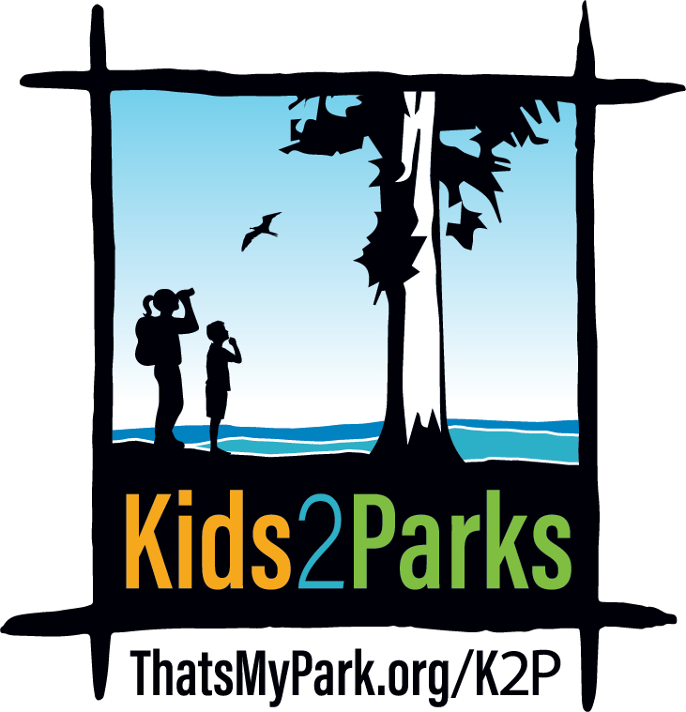

Frequently Asked Questions

Q: What is Kids2Parks?
A: Kids2Parks is a partnership between Friends of Santa Cruz State Parks and California State Parks that strives to ensure State Parks are accessible to all children by enrolling Title 1 students on a State Park field trip. If needed, the Kids2Parks program pays for all the field trip transportation costs, including bus rental, driver time and fuel, and also funds State Parks staff time to support the field trips. The program seeks to broaden the number of students who have visited a state park or beach, ensure there are no barriers to access and invite students to come back with their families to use the parks’ many amenities throughout the year.

Q: Why was Kids2Parks started?
A: Kids2Parks was created to enable access to State Parks for school children of all socioeconomic backgrounds. Kids2Parks sponsors field trips for school children who would not otherwise be able to visit State Parks due to lack of funding, parent participation/chaperones, or transportation. Both Friends of Santa Cruz State Parks and California State Parks are committed to ensuring that folks are aware of and get to enjoy their local state parks.

Q: Who is eligible for Kids2Parks field trips?
A: Title 1 schools from Santa Cruz, San Mateo and Santa Clara counties.

Q: Why don’t all students have equal access to State Parks’ field trips?
School districts budget cuts impact the ability of districts to maintain a fleet of school buses, causing field trip transportation to the parks to depend on parents to be capable and available to drive students. Less wealthy families that have two working parents often are unable to help transport students because 1) they are at work; 2) they often own only one car or rely on public transportation; 3) the type of work they do is often the type where they have very little flexibility. Therefore, many children in less wealthy school districts are disadvantaged by the inability to get to State Parks on school field trips.

Q: Why are Title 1 schools the only ones eligible for Kids2Parks?
A: Title 1 means that more than half of the students at a given school come from economically disadvantaged families. These schools are the least likely to be able to afford field trips, while many other schools have parents with more flexible work schedules and extra vehicles to chaperone field trips.

Q: How many field trips are awarded?
A: There is a limited number of field trips based on State Park staff and volunteer/docent capacity, as well as available funding for transportation.

Q: Which parks offer Kids2Parks field trips?
A: The program currently includes Castle Rock State Park, Castro Adobe State Historic Park, Half Moon Bay State Beach, Henry Cowell Redwoods State Park, Natural Bridges State Beach, the Forest of Nisene Marks, the Rancho Del Oso Unit, Seacliff State Beach and Wilder Ranch State Park. At this time schools are chosen for specific parks based on their geographic distance to the park.

Q: What is the age range of students attending Kids2Parks field trips?
A: Currently field trips are open to elementary school students.

Q: Where does the funding for these trips come from?
A: Funding has been committed by Friends of Santa Cruz State Parks as well as local grants and generous individual donors. To donate please visit: https://www.thatsmypark.org/donate

Q: How many years has Kids2Parks been an active program?
A: Kids2Parks began with a small pilot program in 2016, with six classes in Pajaro Valley School District. In 2017, the program organized 20 field trips. In the 2018/19 school year, 2,820 students are being served through 49 field trips.

Q: What costs does Kids2Parks cover?
A: If needed, Kids2Parks covers all expenses related to transportation to the parks. The cost is usually $300-$550 per trip. Kids2Parks funding also is used to pay for State Parks staff time to host the additional field trips, coordinate volunteers, and administration costs of the program.

Q: Can teachers select the state park or beach where they would like to take their class?
A: Title 1 schools from Santa Cruz, San Mateo and Santa Clara counties are assigned a range of parks to choose from, based on proximity to the school.

Q: How are classes selected for field trips?
A: Teachers must submit a request online at www.thatsmypark.org/K2P during the application time period. Field trips will be allocated on a first-come, first-served basis.

Q: Is transportation cost the main obstacle for Title 1 schools sending classes to state parks?
A: California State Parks and Friends of Santa Cruz State Parks studied the deficit of school field trips before launching Kids2Parks and the cost of transportation was the most often noted barrier and the hardest to overcome.

Q: Is there anything I must do to prepare my students for a Kids2Parks field trip?
A: To ensure students have a rewarding and high-quality educational experience during their K2P field trip, each class is required to participate in a 30 minute pre-trip videoconference program with the park interpreter who will be leading the field trip. This allows the interpreter to introduce themselves and share important information about visiting the park so students will be better prepared for the field trip, and it provides students a chance to ask questions about what to expect during their visit and familiarize themselves with the park interpreter. The park interpreter will contact teachers to schedule these videoconferences and explain how to connect for them.

Q: Is there anything I must do after our Kids2Parks field trip to conclude the experience?
A: Following your field trip, a short online survey will be sent by the park interpreter. Completing this 5-minute survey will help us improve participants' experience and secure funds to expand the program in the future. We greatly appreciate teachers taking the time to fill it out.

Q: How can teachers and schools who are ineligible for Kids2Parks funding arrange field trips to State Parks?
A: Teachers can always apply for field trips outside of Kids2Parks at https://www.thatsmypark.org/visit/field-trips/ or contact the State Park you would like to tour directly.

Q: What is the difference between a Kids2Parks field trip and a regular field trip at a state park or beach?
A: The content of the field trip is the same as a regular field trip. Outside of the Kids2Parks program all schools are eligible for all State Parks field trips. The difference is Kids2Parks covers transportation costs because the Kids2Parks program works to ensure that Title 1 schools have the opportunity to enjoy and explore our local State Parks.

Q: If a school has already had one class selected for a Kids2Parks trip, are other classes less likely to be chosen?
A: At this time, we have a limited number of field trips available and they will be chosen on a first come first served basis. However, priority will go to teachers who haven’t been on a field trip regardless of the school.

Q: What do students do on the Kids2Parks field trips?
A: Every field trip is different. Please refer to www.thatsmypark.org/K2P for specific information on each tour available.

Q: Can students with mobility needs attend Kids2Parks field trips?
A: Yes. All field trips are designed to be accessible to students regardless of their mobility needs.

Q: When can teachers submit a request to participate in Kids2Parks?
A: The form will be available at www.thatsmypark.org/K2P on April 1, 2019 and the application window will close April 30, 2019. State Parks will award the field trips by the end of May 2019. Teachers are encouraged to submit their request early.

Q: How can community members donate to Kids2Parks?
A: Contact Jo Kenny, Parks Philanthropy Director, at 831.429.1840, ext. 312 or Jo@ThatsMyPark.org, if you’d like to help fund Kids2Parks. You can also visit https://www.thatsmypark.org/donate

